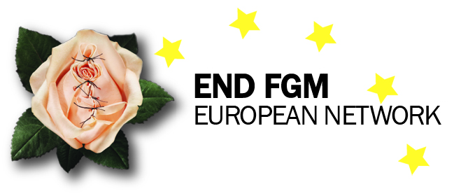

Charter – End FGM European Network

The END FGM European Network is committed to working towards a world where women and girls are empowered and free from all forms of gender based violence in particular female genital mutilation (FGM).
The Network agrees and advocates for a holistic approach to ending FGM and other forms of violence against women (VAW) at European level and channels members’ efforts towards common goals and demands. It aims to create an enabling environment for coordinated and comprehensive actions by European decision makers and civil society organisations. It is guided by a human rights based approach (Express Link to human rights, Empowerment, Participation, Non-discrimination/Equality, Accountability).
The network provides a space where member organisations can share their experience and diverse skills. It aims to support the empowerment of women, girls and affected communities by facilitating their active participation in actions to end FGM and VAW.

This Charter outlines our common commitment to excellence, strong governance and transparency of both finances and activities. As an organisation and part of the END FGM European network we agree to:
- Adhere to the vision, mission and values of the END FGM European Network
- Respect and promote human rights and gender equality in our activities
- Ensure that our advocacy is grounded in agreed common strategies, positions and procedures
- Use and promote empowering language framed in human rights in relation to women and girls living with FGM and affected communities, and avoid stigmatising language
- Promote the active participation of rights holders in decision-making and activities
- Enable members’ ownership by taking an active stance in the network and its commonly agreed action to end FGM and VAW
- Be accountable, transparent and deal with professionalism, accuracy and integrity in all its work to end FGM and VAW
- Promote and provide solidarity between organisations and respect for staff, members, individuals, allies and all stakeholders
- Refrain from any activities or actions which would undermine or negatively impact on the Network or its members
- Ensure that conditions stated in the statutes for membership are met in accordance with your membership status

By signing the Charter of the END FGM European Network my organisation respects the principles spelled out in the Charter, the Statutes and the Strategic Plan of the END FGM Network.

Name of signatory
Legal Representative of the Organisation
Date and place

____________________________________________________________________

