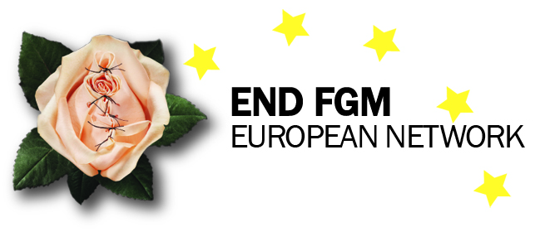

Welcome to the first

END FGM Newsletter!

Dear supporters,
- Many of you have been supporting us for years as part of the End FGM European Campaign. Thank you for your support, encouragement and commitment to ending FGM in Europe and beyond!
Amnesty International’s End FGM European campaign ended in December 2014, but the work will continue through a newly set-up NGO called the END FGM European Network
- The Network will ensure sustainable European action to end FGM.
- We hope you will continue to support our action. We will be sending out a newsletter every two months to keep you updated on our work, that of our members and the work going on at European level to end FGM.
As part of the transition from Amnesty campaign to independent network, we have moved to our new office.

You will now find us at:
END FGM European Network, Mundo B, Rue d’Edimbourg 26, Brussels 1050, Belgium. (http://www.mundo-b.org/)

- Email:info@endfgm.eu
- General office number: 0032 2 893 0907

HIGHLIGHTS ON EUROPEAN UNION DEVELOPMENTS
- The European Commission released a joint statement on 6 February for the International Day of Zero Tolerance to FGM where it details the EU action and commitment to ….
- The European Parliament held a debate in plenary session on 10 February and put an oral question to the Commissioner for Justice and Gender Equality, Vera Jourova, on FGM.
- In January, Latvia took over the Presidency of the EU until July. Its programme can be found here. The Presidency will lead the discussion on behalf of the EU at the next CSW and in international discussions on the post-2015 development framework. Tweet them with your wish list at @eu2015lv
Ahead of the 8th March, the European Parliament held several different events. Leyla Hussein spoke at an S&D event on Women for Change, Change for Women on FGM during a panel discussion on Violence against women. She highlighted the need for the EU to support survivors and those at risk by signing, ratifying and implementing the Istanbul Convention.

END FGM at work
Since the Network started to take office in January 2015, we’ve been busy raising awareness and informing stakeholders about our work and what Europe should do to support our action at different events around Europe. Here’s a summary of our actions.

Secretariat
- The Network took part in an exchange of views with the European Parliament’s Women’s Rights and Gender Equality Committee on 20th January. We presented the recently established Network and called on MEPs to ensure the EU continues to prioritise the elimination of FGM, in particular in its next gender equality strategy. The hearing can be viewed here.

- The End FGM European Network was also on the panel at the Public Policy Exchange Conference Free From Fear, Free from Pain: Eliminating Female Genital Mutilation in Europe on 20th January. We presented the measures in place at European level on FGM. There were some powerful speeches from survivors, such as Assita Kanko [a link to her book can be found here] and examples of best practice for providing support services for survivors and professionals from our members Intact and GAMS Belgium.
- On 26 January, the Network and several of its members participated in the European Commission Roundtable on the implementation of the European Commission’s action plan on the elimination of FGM. The Roundtable was an opportunity to take stock of EU developments on FGM and to provide recommendations on how to improve the current or future implementation of the current EU actions.

- The Change Conference organised by Terre de Femmes in Berlin on 28th January [Programme here] was an opportunity for the Network to present its work at EU level and the Guide on the Istanbul Convention. Our members FSAN, Forward UK and Equipop also introduced their work with professionals and communities and training of change agents. Change agents shared their experiences about how FGM should be integrated into broader community discussions. German and UK government departments also presented their priority action on the issue.

- END FGM acts as a platform for rights holders to meet with decision makers. The Network was invited to speak alongside END FGM strong voice Aissatou Diallo at the European Parliament Socialist & Democrat Group meeting on Tuesday 3rd February, ahead of the International Day of Zero Tolerance to FGM. Aissatou explained how she works together with her community and advocates at local, national and European level to raise awareness and prevent FGM. She called on MEPs to keep FGM high on the EU agenda. Elise introduced the Network and highlighted the need to prioritise prevention as the most sustainable way to end the practice. You can watch Aissatou being interviewed before the event here.

- The Network was invited to present the Guide on the Istanbul Convention as a tool to end FGM at the European Learning Forum London on 5th February. The Forum gathered representatives from various EU countries (e.g. Belgium, the Netherlands, Portugal, Greece and Finland) to exchange good practices on programmes to work towards ending the practice in their country. The guide is now also available in French.

- We also participated in the UK government Zero Tolerance to FGM Inter-ministerial meeting on 6th February, which aimed to take stock of developments after the July Girls Summit. here].
- IMPORTANT! We launched our Network Strategic Plan online on Friday 6th February. The strategic plan shares our vision, mission and values and sets out the Network’s strategic priorities and objectives for 2015-2017.

- On 9th February, the Network co-hosted with the World Future Council the first meeting of the informal Istanbul Convention CSOs watch group, which gathered European Networks working on women’s rights (EWL), violence against women (WAVE), LGBTI (ILGA Europe and Transgender Europe), sexual and reproductive rights (EPF), migrant rights (PICUM, ENoMW) and human rights (Amnesty International, Human Rights Watch). The group committed to undertake coordinated actions in relation to monitoring the ratification and implementation of the Istanbul Convention.

- We became members of the Girl Generation at the end of February, making END FGM a European focal point in the global movement to end FGM. The Girl Generation is a global campaign that supports the Africa-led movement to end FGM. We look forward to working with organisations around the globe on ending FGM How does it fit with the Network’s objectives? Being part of the Girl Generation will help the Network in achieving its objective of building bridges between relevant actions to end FGM. What do we expect?

Communications
Stay up to date over social media
- You can still find us on Facebook and Twitter at the usual addresses. Our website is also the same: www.endfgm.eu

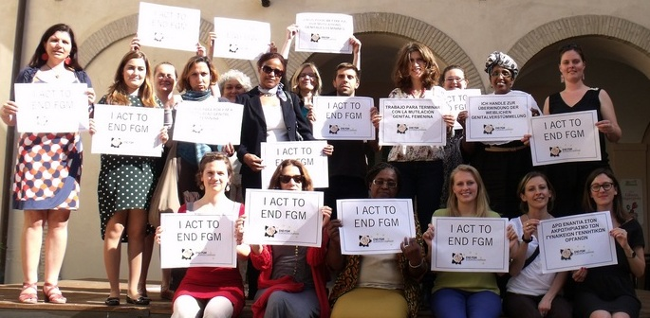

NEWS FROM OUR MEMBERS
A brief overview of what our members have been doing.

News from Italy
- AIDOS has a new President, Maria Grazia Panunzi. She has been working with the Association since 1997 and in the past 18 years, has been involved in the development of AIDOS strategies and advocacy activities both at national and international levels, and in the coordination of field projects.
- On 6th of February AIDOS organised a press conference on FGM as a European issue and Clara Caldera presented the Guide to the Istanbul Convention as a tool to end FGM. Participants included : Pia Locatelli (Italian MP), the new President of AIDOS Maria Grazia Panunzi, Elise Schlein, an Italian MEP, Mara Carfagna (Italian MP)
- The 9th and 10th February AIDOS participated in an event organised by the Italian department on equal opportunities.

News from Portugal
- On 6th February APF launched a flash mob video produced during the 2014 International Day for the Elimination of Violence against Women. They also participated in the official ceremony promoted by CIG (Portuguese commission for gender equality) and together with UMAR ONG they held several street actions that include a photo opportunity in front of END FGM Mural in Lisbon and distributing informative materials in several strategic spots in the city.
- On Wednesday, 4th of February, APF started promoting inscriptions to a workshop about FGM and forced marriage themes for journalists, a partnership between APF and CENJOR - the main school for communication professionals in Portugal.

News from Belgium
- Intact and GAMS Belgium organised an event with the Institute for Equality of women and men on 5 February launching an anti FGM kit for professionals. (LINK )
- GAMS organised a whole day of youth events on 4th February, which were supported by two ministers and were well attended by school children, affected communities, teachers and CSOs.
- The national launch of Stratégies concertées MGF (concerted strategies for fighting FGM) also took place during the weekend of 7/8 February.

News from France
- Equipop took part in an event in Paris to say NO to FGM (“Non à l’excision”).This event was organised by the umbrella organisation Excision parlons-en and several organisations in France took part in the action, both at the public demonstration and also through a social media action on Facebook.
- You can find Equipop’s statement released on International Women’s Day on 8th March.

News from the UK
- Forward UK took part in a conference on 22nd January to strengthen youth engagement in ending FGM and forced marriage.
- On 6th February, Forward UK called for mandatory training of all UK health professionals and frontline staff.

News from the Netherlands
- FSAN took part in a conference on 6th February on the obligation to protect. FSAN spoke about change agents and the participatory approach of the Somali community in the Netherlands.

What’s coming up next?
- The theme of this year’s International Women’s Day on 6th March is Empowering Women, Empowering Humanity. We have been releasing a series of images on social media to highlight our vision of ending FGM.

