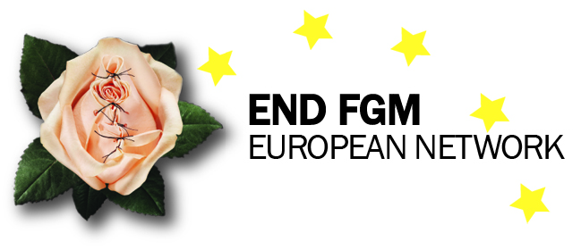

END FGM Newsletter!

Welcome to End FGM European newsletter, where we bring you up to date on the news on developments at European level on FGM related matters, as well as news from our members

END FGM at work
Here’s a summary of our actions raising awareness and informing stakeholders about our work and what Europe should do to support our actions at different events around Europe.
- 9th European Forum on the Rights of the Child 3rd and 4th June. Several members of the Network attended the European forum on the rights of the child and took part in different discussion groups; the network was therefore represented in as many different discussions as possible. You can see all presentations and a summary of the discussion here.
- Study on Exchange of best practice Anna Powers – Anna Powers, a medical student from the USA stayed with the secretariat for two weeks in June to create a report on best practice on ending FGM in Europe. She devised a questionnaire, with the help of our Treasurer and Director of GAMS, Fabienne Richard, and met the members of the network. The Network will have access to Anna’s report and will publish the results to enhance the exchange of best practice across Europe on FGM.
- The Network was invited to speak at the Council of Europe Parliamentary Network On Violence Against Women in Strasbourg on 24th June. Our President Naana Otoo-Oyortey spoke about the Istanbul Convention as a tool to end FGM. This was an important opportunity to highlight the link between the Istanbul Convention as a tool to end FGM and the importance of doing so using a coordinated approach.
- Member of the Council of Europe, Beatrice Fresko-Rolfo, will be writing a report on FGM in 2016. The Secretariat has reached out to her and we hope to support her in the preparation of her report. Ms Beatrice Fresko-Rolfo will hopefully also attend a conference organised by Intact and GAMS in Belgium in October.
- Two new members of staff joined the Secretariat office in August! Jean-Philippe Faujour is our Administrative and Finance Officer and Celine Fabrequette is our Advocacy and Communications Assistant. You can read more about them here. We welcome them warmly to the team!
- As part of alliance building and information sharing with civil society organizations, the secretariat met with Julia Ehrt and Richard Kohler from Transgender Europe on 15th September. We shared information on EU developments and discussed the political environment, strategies and challenges of working on gender rights at EU level.
- The Council of Europe Group of Experts on Action against violence against women and domestic violence (GREVIO) held its very first meeting on 18th September. Several civil society organizations, including the Network and MIGS, sent a letter to GREVIO asking them to be proactive in seeking the input of NGOs and offering approaches to be considered when it comes to monitoring the implementation of the Istanbul Convention.
- The network contributed to the Inter-Agency Expert group online consultation on SDG indicators, the deadline for which was 7th September. Our recommendations included adding girls under the age of 15 to the indicators, as the majority undergo FGM before the age of 15. We also recommended deleting references to ‘relevant countries’, as FGM is a global practice affecting countries across the world.
- Victim Support Europe held a seminar with the European Commission’s DG Justice on the Victim’s Rights Directive. The deadline for transposing the directive in national legislation is 16th November 2015. Civil society organisations shared their plans and priorities on victims’ rights for the upcoming months. The Network updated the group on the Q&A guide we are developing for members to support them to better understand the implications of the Victim’s Rights Directive for FGM related cases and how they can monitor its implementation.

Communications
Duplicate and reach targets via social media
- 1st August marked one year since the entry into force of the Istanbul Convention! The Council of Europe released a video to mark the event, including part of an interview with our president, Naana Otoo-Oyortey.
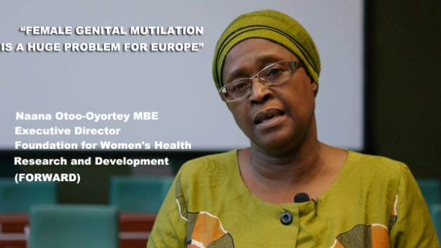

- Our favourite member Facebook post this month is:
The AIDOS Facebook post on the training of journalists and communications experts in Kenya. We found the images moving and evocative, as did many other people! Check it out!
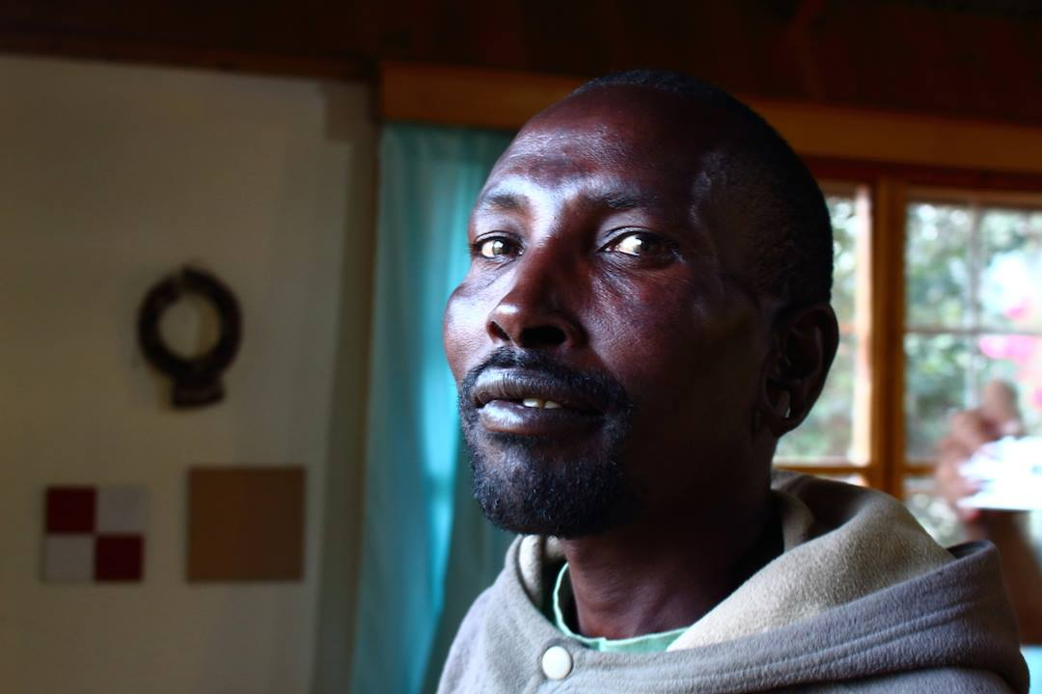

@ Website: Please help us to keep your organisation’s profile up to date on our website too – if you see anything that is out of date with regard to your organisation, please let us know and we will rectify it.
Ahead of the launch event of the network on 2nd December, we will be modernising our website to make it more user-friendly. More information on this soon!

How to reach us

Our new office address:
END FGM European Network, Mundo B, Rue d’Edimbourg 26, Brussels 1050, Belgium. (http://www.mundo-b.org/)

- General office number: 0032 2 893 0907
- Jean-Philippe: 0032 2 893 0904
- Natalie: 0032 2 893 0902
- Céline: 0032 2 893 09 07

HIGHLIGHTS ON EUROPEAN UNION DEVELOPMENTS
- Following the Gender Forum in April, the European Commission launched an online consultation on the post-2015 Gender equality strategy. The Network contributed to the online consultation.
- As previously mentioned, following the Child Rights forum, DG Justice opened a public consultation on the use of the ten principles and how they might be used in our work.
- EIGE published a study on the estimation of girls at risk of FGM on 8th June. The study tested a new methodology for estimating girls at risk of FGM in Portugal, Ireland and Sweden, found that cooperation between governments and communities in preventing the practice of female genital mutilation in Europe and beyond was very important.
- The deadline for transposing the Victim’s Rights Directive into national legislation is 16th November 2015. This means that European member states must ensure that the provisions in the directive on the rights, support and protection of victims have to be incorporated into national legislation by this date. The Network is producing a guide for our members to explain the implications for those affected by FGM and professionals working on this issue.
- The Luxembourg Presidency will hold a meeting on the Victim’s Rights Directive on 16th November. The Secretariat will attend and raise our concerns with regard to monitoring the implementation of the Directive and specialized training and provision of services for those affected by FGM and professionals working with these communities.
- The Council of Europe GREVIO Group of experts in charge of monitoring the implementation of the Council of Europe Istanbul Convention elected their president and vice-president on 22nd September. The two vice-Presidents, Rosa Logar and Marceline Naudi, are part of the civil society group monitoring the Istanbul Convention, so we have a good relationship with them. The task seems to be in good hands! We will continue to build our relationship with them to ensure a coherent approach.
- On 8th September the European Parliament adopted MEP Laura Ferrara's report on Fundamental Rights. The report urges Member States and the European Union to sign, ratify and implement the Council of Europe Istanbul Convention and also demands that professionals working with those at risk and/or affected by FGM are provided with adequate training.
http://www.europarl.europa.eu/…/Fundamental-rights-MEPs-hig…

NEWS FROM OUR MEMBERS

News from Belgium
- Intact and GAMS are organizing a joint conference in the Belgian parliament on 23rd October on the Istanbul Convention as a tool to end FGM. There will be speakers from the European Commission, the Council of Europe and UNHCR, among others. You can find more information about the Conference here.
- GAMS has been rolling out training courses for medical professionals in both French and Dutch. The comprehensive course takes a holistic approach and covers social, cultural and psychological aspects, as well as discussing the legal approach and offering training on real life case studies and how professionals might handle those.
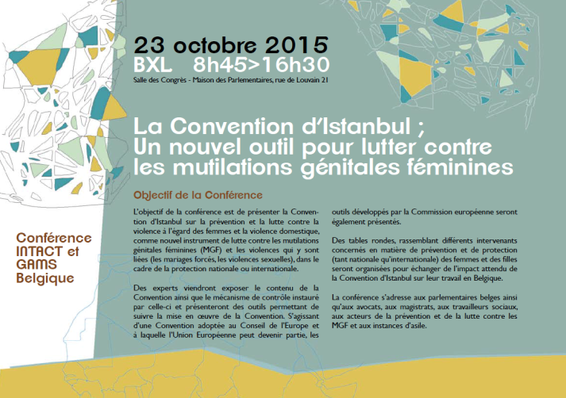
- The Men Speak Out project organised by GAMS Belgium, Forward UK and Himilo Netherlands is also progressing and the training of male peer educators is now under way.

News from Cyprus
The Mediterranean Institute of Gender Studies (MIGS), in collaboration with the Cyprus Island-wide NGO Development Platform, organised a training course entitled “Addressing FGM in Development Programmes and Projects”. The 2-day training took place on 14-15 September 2015 at the Ministry of Foreign Affairs, in Nicosia-Cyprus.
The training course took place within the framework of the EuropeAid Project “END FGM (Female Genital Mutilations). Cooperation, synergies and structured dialogue among civil society and EU institutions to address female genital mutilation as a development issue”, funded by the European Union and coordinated by AIDOS (Italy) in partnership with FORWARD (UK) and APF (Portugal).
The 2-day training course in Cyprus was organised within the framework of the European Year for Development 2015 and under the auspices of the Ministry of Foreign Affairs. “Although many policy-makers and diplomats don’t know about FGM, I strongly support the efforts to combat this form of violence and support women, girls and their communities to live free from violence”, H.E. Alexandros Zinon, Permanent Secretary, Cyprus Ministry of Foreign Affairs.
The aim of the seminar was to involve Non-Governmental Organizations / No-State-Actors/ civil society organizations and local authorities in development cooperation (local, Europe, and Africa) through the enhancement of knowledge and skills to integrate FGM abandonment in development programs.
The training course had the following learning objectives:
- Increase understanding of the cultural environment and the reasons behind the FGM as a cultural practice;
- Improve understanding of FGM as a gender and development issue;
- Develop skills and capacities of trainees to adopt strategies, tools and approaches to end FGM in development project and programmes.
Participants to the training course included officers of the Ministry of Foreign Affairs dealing with human rights, sustainable development goals, and external relations with EU and affected countries. Among the training participants were officers of the Cyprus Asylum Service, and NGOs such as the Future Worlds Centre, Hope for Children, NGO Support Centre, MIGS and other activists and researchers interested to mainstream FGM in their projects.
The training participants expressed their satisfaction and appreciation about the training’s theoretical and practical/interactive content. In a positive environment together with the trainer Anna Zobnina (MIGS) and Christina Kaili (MIGS, END FGM Board Member) the participants joined forces to share experiences and current realities about FGM in Cyprus and discussed new joint actions to promote much needed multi-agency cooperation with regards to mainstreaming FGM in existing work in Cyprus, in Europe and beyond.
Stay tuned for the series of publications of this project (4 factsheets and position paper) in English, French, Greek, Portuguese and Italian.
For more information please contact Christina@medinstgenderstudies.org.
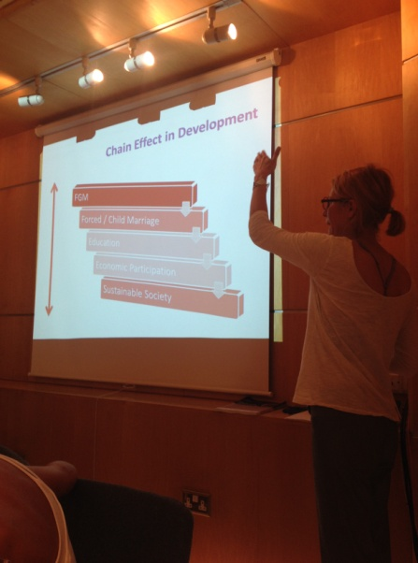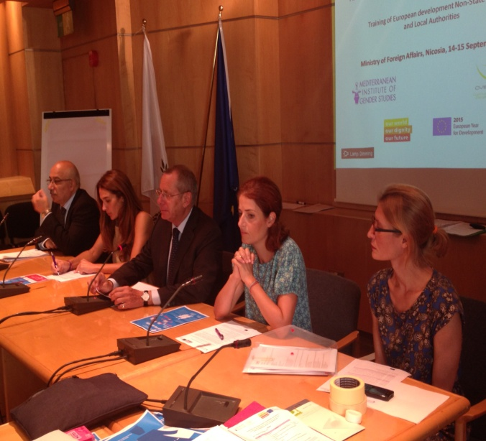

News from France
- EquiPop took part in the training course organised by AIDOS in Senegal to produce audio documentaries on FGM:
http://equipop.org/index.php/acttualites/48-actualites-d-equipop/284-creation-d-un-documentaire-sur-les-mutilations-genitales-feminines
- . At EquiPop's General Assembly at the end of September, the focus was on the work they are doing with migrants in France to promote abandonment of FGM. Roukiatou Sissoko, one of Equipop’s peer educators, had the opportunity to speak. "As long as there will be FGM in my community, I will keep on fighting against this harmful practice" she said.
http://equipop.org/index.php/acttualites/48-actualites-d-equipop/286-retour-sur-l-assemblee-generale-2015-d-equilibres-populations

News from Germany
- At the request of the local population, the FULDA-MOSOCHO-PROJECT for the protection of girls at risk of FGM has expanded its work in western Kenya to encompass the regions of Marani and Kisii South. Thanks to financial support from the AlternAid Foundation we have been able to take further important steps. The highlights in September were two network meetings, each attended by more than 100 high-ranking stakeholders, such as mayors, school directors and community leaders, and including opinion leaders mobilized in 2011. The two network meetings, intensively organized in collaboration with an anti-FGM expert from the German partner LebKom e.V. and officially opened by the responsible school authorities and the assistant sub county commissioner, were a success. Further steps for the protection of girl children and the improvement of life within families were discussed on a broad basis and jointly resolved.
- As part of LebKom e.V.’s educational work on development policy, teaching units were introduced in several schools in Germany to address the question ‘What does the subject of FGM have to do with us?’ Pupils, both boys and girls, were motivated to explore the subject from various perspectives, for example through the use of role-playing.
- At the request of the Hessian development policy network, LebKom e.V. delivered a speech on sustainable development cooperation, with a focus on how to overcome FGM effectively.

News from Italy
- On the 18th of July the Italian Chamber of Deputies unanimously approved the motion against early and forced marriage; the first signatory was Pia Locatelli, coordinator of the Parliamentary Working Group on "Global health and rights of women", whose secretariat is managed by AIDOS. With this motion, the government commits itself to “implement the UN resolution against early and forced marriage; to support a renewed global campaign to prevent and eliminate this practice which violates the human rights of girls, and to provide financial support for programs and projects of international cooperation for the prevention and abandonment of early/forced marriages”.
(http://parlamento17.openpolis.it/singolo_atto/31981)

- In September AIDOS organised a training course on how to produce radio documentaries on FGM in Lukenya (Kenya) in partnership with a local and an Italian media association (AMWIK and Audiodoc). Twelve radio journalists and communication officers from Kenya, Tanzania and Uganda participated and produced together 3 audio documentaries in English. Furthermore, each participant wrote a project and the authors of the more interesting ones were awarded an equipment kit and a monetary prize to create their own radio documentaries in local languages. All the documentaries will be broadcast in English and in local languages by national and community radios from the 3 countries airing in practising areas. All the activities are in the framework of a UNFPA-UNICEF Joint Programme on FGM/C funded project, "Abandoning FGM on FM!", that aims at building the capacity of African media practitioners and at using radio as a powerful tool to promote behavioural change.
To mark this occasion, AIDOS posted a series of pictures on Facebook, portraying those interviewed for the radio documentaries. You can find the post here ; it was one of AIDOS most popular this year. 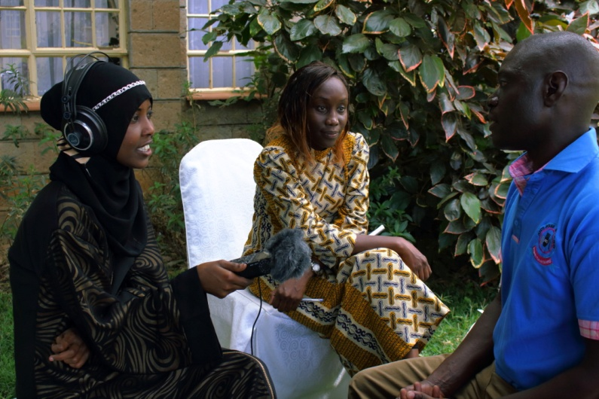

News from the UK
Two New Papers Examine the Law and FGM in Tanzania and the UK
Two papers have been published on FGM and law in Tanzania and the UK in collaboration between FORWARD and Lisa Avalos, assistant professor of law at the University of Arkansas School of Law. Ending Female Genital Mutilation and Child Marriage in Tanzania, published in Fordham International Law Journal, looks at the context in which these practices persist in Tanzania and outlines statutory law reforms to dismantle the cycles of gender based violence. Female Genital Mutilation and Designer Vaginas in Britain: Crafting an Effective Legal and Policy Framework was published in Vanderbilt Journal of Transnational Law. This paper analyses Britain's legal and policy approach to FGM, addressing the gaps in the law, in particular the double standard between FGM and so-called 'designer vagina' surgeries and concludes with a model FGM law for the UK.
- The UK Government is currently consulting on Mandatory reporting of girls under18 years who have undergone FGM. FORWARD welcomes the new policy developments in the UK on FGM, which address a number of loop holes that FORWARD has lobbied for over the past years. However, FORWARD urges the UK government to support girls affected by FGM and ensure that safeguarding girls at risk should also include funding for community engagement programs and support the best interest of the child in all cases of FGM.

WONDERING WHAT’S COMING UP NEXT?

- The Network will attend an event organised by Excision Parlons-En in Paris on 9th October on the vital role that professionals can play in prevention of FGM in France.
- 11-17 October is European Week of Action for Girls! The Network will take part in several events hosted by the European Parliament, the Luxembourg Presidency and civil society organizations. Keep checking our social media for more information and photos!
- The Network will attend a conference hosted by the Council of Europe on the Istanbul Convention on 20th October on monitoring the implementation of the Istanbul Convention. The high level conference will attended by national and international decision makers, NGOs and professionals.
- The Network is planning its launch event and a conference on the best interests of the child in FGM related cases on 2nd December! More details on both of these events soon!

AOB
- Please make sure that you communicate with us on the following email addresses:
- Natalie Kontoulis : nkontoulis@endfgm.eu
- Jean-Philippe Faujour : jeanphilippefaujour@endfgm.eu@endfgm.eu
- Céline Fabrequette : intern@endfgm.eu

- We have created a mailing list with member names. If you think other colleagues in your office who would be interested in receiving our updates, please do share their contacts with us.

